1. write a script to print the date and redirect it to output.txt?

1. create a file or folder using the date as the name?

1. i) Create a bash script to print the local time, date, username of your system, and your current path.

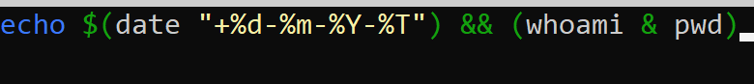

ii) After printing, redirect the output into a file called output.txt

**iii) Insert output.txt into a new directory, where the directory name is the current timestamp**.

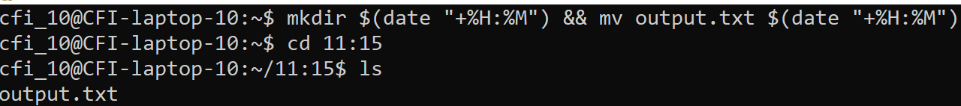

1. **Create a bash script to execute the date every 2 minutes once on Saturdays only.**

**5. Take a backup of a folder every month twice?**

**6. Print the count of the number of files in a file called count.txt**?

**7. Create files dynamically every day at 12 AM where the file name is a date?**

CRONTAB SCRIPTS LABS:

**1. Write a script to print the current directory and username and redirect it to a file called output.txt?**

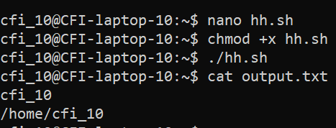

**2. Create a file with the current timestamp as its name inside a folder with the current date as its name?**



3. Create a bash script to print the local time, date, username of your system, and your current path and redirect the output into a file called output.txt. Insert output.txt into a new directory, where the directory name is the current timestamp.

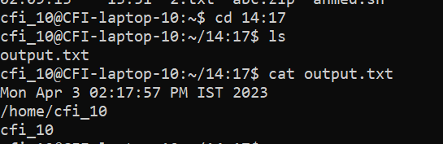



**4. Write a script to print the count of the number of files in a folder and redirect the count to a file called count.txt.**

**(Reference: Google about word count and pipe commands in Linux)**

**5. Create a bash script to execute the date every 2 minutes once on weekends only?**

**6. Take a backup of a folder daily twice?**



Soft Links/Hard Links

1. MODIFY any SOFT link and observer original?

**ANS: The original file will also get modified**

1. MODIFY original file of SOFT link and observe?

**ANS:** **Soft Links will also get modified, if we modify the original file.**

1. Remove any SOFT link and observer original?

**ANS:** **If we remove the soft link, the original file will still be available.**

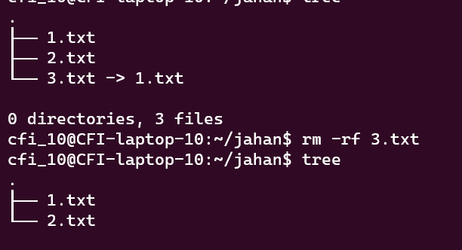

2. Remove original file of SOFT link and observe?

**ANS:** **Soft Links are invalid once the source or parent file is deleted**

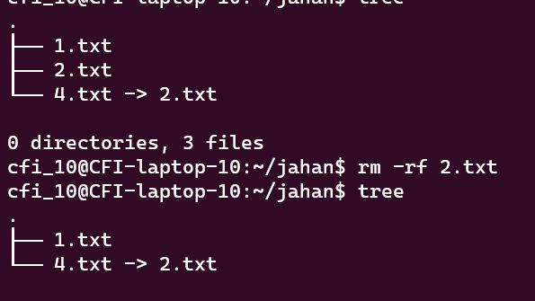

1. MODIFY any HARD link and observer original?

**ANS: Modifying a hard link will also modify the original file.**

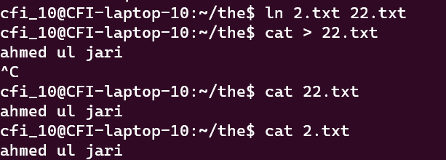

1. MODIFY Original file of HARD link and observe?

**If we change the permissions on the source file, the same permission will be   
applied to the hard link file as well.** 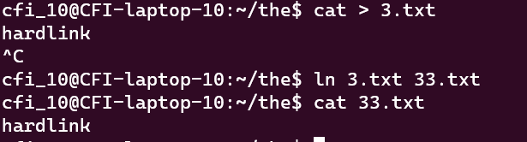

1. Remove any HARD link and observer original?

**If we remove the Hard link, the original file will still be available**

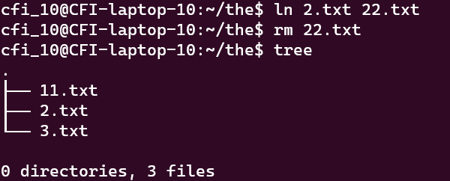

4.Remove original file of HARD link and observe?

**Removing the source file won’t affect the hard link**

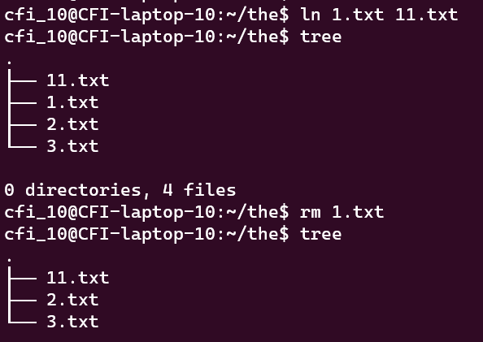

**Comparison among soft, hard, copy?**

|  |  |
| --- | --- |
| Hard link | Soft link |
| It has the same inode number | It has different inode number |
| Changes made in any file will reflect all files | If the original file gets deleted, the soft link will also get deleted |
| It acts as a copy of a selected file | Acts as a reference to the file name |
| If we change the permissions on the source file, the same permission will be applied to the hard link file as well. | Soft links and source file will have different permissions |

**what are wget , curl commands differences?**

Wget

* Wget is a tool to download files from servers.
* Wget or GNU wget is another open-source free command-line tool

for transferring files using HTTP/HTTPS, FTP, and FTPS.

* The name is a combination of **World Wide Web** and the word **get**.

Curl

* Curl is a tool that exchange request/response with a server.
* Curl is a free and open-source command-line utility tool that allows the users

as well as the developers to transfer data without any UI interaction. It is

commonly used in routers, mobiles, etc.